EVALUATION TOOL SELECTION GUIDE
Choosing an LLM and Agent Evaluation Platform
Braintrust vs AWS AgentCore Evaluations vs Langfuse vs Arize AX: what each does, how it looks, where it is strong and weak, and when to pick it
■ Braintrust Managed SaaS, eval-first, strong experiment UX
■ AWS AgentCore AWS-native managed agent evaluations in CloudWatch
■ Langfuse MIT open source, self-host free, or Langfuse Cloud
■ Arize AX Managed platform on OpenTelemetry / OpenInference
Version 1.1 · 19 October 2026
Facts checked against vendor documentation on 19 October 2026. Prices and features change often; re-check before signing anything.
Contents
1. Summary 3
2. Why evaluate LLM apps and agents 4
3. What a tool must do: the four must-haves 6
4. Braintrust 7
5. AWS AgentCore Evaluations 10
6. Langfuse 13
7. Arize AX 17
8. Side-by-side comparison 20
9. Decision guide 24
10. Sources and caveats 25
Appendix: more screenshots 27

1. Summary
There is no single best evaluation tool. All four score production traffic well and all four run test sets (AgentCore's managed datasets are still in preview); they differ on where your data can live, how they gate releases, how deeply they understand agents, and how they charge.
The table gives the recommended pick for six common situations. It is the same list as section 9.2, which also gives a runner-up and tie-breaks; the decision flow in section 9 leads to the same answers.
Your situation | Pick | Why
The whole tool must run on our own infrastructure; no licence fee | Langfuse (self-hosted) | MIT licence; judges, datasets, experiments, annotation queues and a CI GitHub Action are free to self-host.
Self-hosted, regulated, agents are core, Enterprise budget available | Arize AX Enterprise (self-hosted) | Agent-path judging, audit logs, SSO, air-gapped install; Langfuse self-hosted is weak on agent paths today.
Agents on AWS; our AWS account and CloudWatch are where agent data lives | AWS AgentCore Evaluations | Managed online, on-demand and batch evals with session, trace and tool-call judges; data stays in our AWS account.
Fast prompt and model iteration; eval results on every pull request; SaaS is fine | Braintrust | Most polished experiment and playground workflow, PR comments via GitHub Action, AI analysis (Loop, Patterns).
Many teams building multi-agent systems; one shared, calibrated judge library | Arize AX (SaaS) | Agent Graph / Path views, versioned Evaluator Hub, judge-vs-human alignment.
Lowest monthly cost, hosted for us (for example a startup) | Langfuse Cloud | Free Hobby tier, then $29 or $199 per month plus usage; about $95 to $265 per month for 100k traces (section 8.3).

What changed recently (worth knowing before you decide)
Langfuse was acquired by ClickHouse, Inc. on 16 January 2026. It stays MIT-licensed, but self-host Enterprise is now bundled with a ClickHouse commercial plan. Langfuse v4 is a breaking upgrade, and trace-level LLM judges stop on Langfuse Cloud on 16 November 2026 (observation-level judges replace them).
AWS AgentCore Evaluations became generally available on 31 March 2026. Managed datasets and user simulation are new but still in public preview.
Braintrust hybrid and self-hosting are Enterprise-only, and the control plane (UI, auth, metadata) is always run by Braintrust.
Arize AX Free includes unlimited online evals, but custom code evaluators, SSO and self-hosting need Enterprise.

2. Why evaluate LLM apps and agents
LLM output is non-deterministic, so ordinary unit tests cannot tell you whether a prompt change, model swap or new tool made answers better or worse. An evaluation platform turns quality into numbers you can track, gate releases on and debug.

2.1 What goes wrong without evaluation
- A prompt tweak that fixes one case silently breaks ten others, and nobody notices until users complain.
- Model upgrades are chosen by gut feel instead of a measured score on your own data.
- Agent failures (wrong tool, looping, bad hand-off) stay invisible because only the final answer is logged.
- Cost and latency creep up with no link back to the change that caused them.
- Risk and compliance teams have no evidence that safety and policy rules were actually tested.

2.2 Offline vs online evaluation
Every tool in this guide covers both, to different depths:
Kind | When it runs | Data it uses | What it catches
Offline (experiments) | Before release, in CI or a notebook | A fixed, versioned dataset of inputs and expected outputs ("golden set") | Regressions from prompt, model, tool or code changes
Online (production scoring) | Continuously, on live traffic | A sample of real production traces | Drift, new failure modes, real-user quality drops

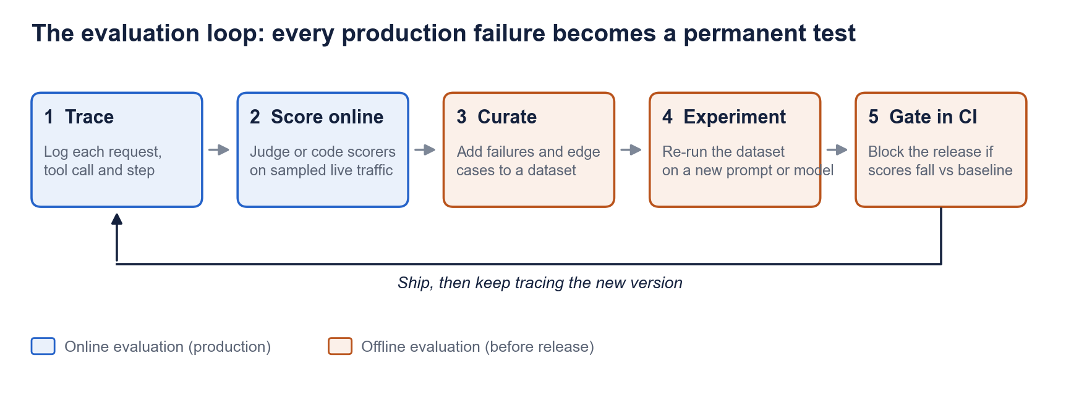
Figure 1. The evaluation loop. Online scoring finds problems; offline experiments and CI gates stop them coming back.

2.3 Kinds of scorer
Scorer | How it works | Good for | Watch out for
Code / heuristic | Deterministic code: exact match, JSON valid, regex, tool X was called, step count under N | Format, tool-use rules, trajectory matching; cheap and repeatable | Cannot judge meaning or tone
LLM-as-judge | A model grades the output against a rubric prompt | Helpfulness, faithfulness, correctness, safety at scale | Judge bias and drift; must be calibrated against humans; costs tokens
Human review | Experts label outputs in a queue | Ground truth, edge cases, calibrating judges | Slow and expensive; needs clear guidelines
Ground-truth comparison | Compare to an expected answer or expected tool path | Regression tests on golden datasets | Golden data goes stale; needs owners

2.4 Levels of evaluation for agents
Agents need scoring at more than one level, because a correct-looking final answer can hide an unsafe or wasteful path:
- Span / tool call: was the right tool chosen, with the right arguments?
- Trace / turn: was this one response correct, faithful and safe?
- Session / conversation: did the user's goal get achieved across all turns, without loops or frustration?

2.5 Terms used in this guide
Term | Meaning
Span (Langfuse: observation) | One step inside a request: an LLM call, a tool call or a retrieval.
Trace | All spans for one request or turn, in order. A trace shows the agent's full path.
Session | All traces in one conversation with a user.
Trajectory | The sequence of tools and steps an agent took. Trajectory evaluation checks that path, not just the answer.
LLM-as-judge | An LLM that grades another model's output against a written rubric. "Agent-as-judge" is an agent that reads the trace itself to grade it.
Golden dataset | A saved, versioned set of test inputs with expected answers or expected tool paths.
OpenTelemetry (OTel) | The open standard for sending traces. OpenInference and the OTel GenAI conventions are its AI flavours; ADOT is AWS's build of it. Instrumenting with OTel lets you switch tools later.
Control plane / data plane | Control plane = the vendor's UI, login and settings. Data plane = where your traces and datasets are stored. "BYOC" (bring your own cloud) or "hybrid" means the data plane runs in your cloud account.
SSO / SCIM / RBAC | Single sign-on; automatic user provisioning from your identity system; role-based access control.
Audit logs | A record of who viewed or changed what in the tool. Usually required by risk and compliance teams.
SOC 2 / HIPAA BAA | An independent security audit report / a contract needed before sending US health data to a vendor.
Licences: MIT, ELv2 | MIT = open source, free for any use. ELv2 (Elastic License 2.0) = source-available: free to self-host, but you may not resell it as a hosted service.

3. What a tool must do: the four must-haves
We judge every tool on four capabilities. Together they cover the full loop: test before release, block bad releases, check agent paths and watch live use.
Capability | What it means | Question to ask the vendor
1. Test sets (offline) | Saved, versioned golden datasets per app, run as experiments with scorers before every release | Can we version datasets, add production traces to them, and compare two runs side by side?
2. Release gates (CI) | The CI pipeline fails when scores drop below an approved baseline, and shows the failing cases | Is there a ready-made CI action that fails the build, or do we script it?
3. Agent steps (trajectory) | Scores tool choice, arguments, step efficiency and hand-offs, not just the final answer | Can a judge see the whole trace or session, or only one span at a time?
4. Live scoring (online) | Scores a sample of production traffic continuously, with filters and alerts | How do sampling, filters and alerting work, and what does each score cost?

3.1 Also worth checking
- Human review: annotation queues, reviewer assignment, turning labels into dataset items.
- Judge governance: versioned judges and calibration of judge scores against human labels.
- Simulation: synthetic multi-turn users to rehearse scenarios before release.
- Red teaming and safety: adversarial prompts, jailbreak and PII checks.
- Hosting and data residency: SaaS, your cloud, fully self-hosted, regions, compliance reports.
- Pricing model: per GB, per score, per token, per span or per unit; this decides cost at scale.

4. Braintrust
Braintrust is a managed platform for evaluating and observing LLM apps and agents. It started eval-first and is known for its experiment, playground and comparison workflow; it now adds AI-driven trace analysis (Loop, Patterns, Topics).
At a glance
Type | Commercial SaaS; SDKs and the autoevals scorer library are open source (MIT), the platform is not
Hosting | SaaS on all plans. Hybrid (data plane in your cloud) and self-hosted data plane are Enterprise-only; Braintrust always runs the control plane
Entry price | Starter $0; Pro $249/month; Enterprise custom
SDKs | TypeScript, Python, Go, Java, Ruby, C# (Rust alpha); OpenTelemetry ingest
Best at | Experiments, playgrounds, PR feedback, fast iteration

4.1 How evaluation works in Braintrust

Offline: datasets and experiments
- Eval() in the SDK runs a task over a dataset with scorers; results land as an experiment you can diff against any other run.
- Scorers: prebuilt autoevals (Factuality, Levenshtein, JSON, SQL and more), LLM-as-judge rubrics, or custom code.
- Playgrounds compare prompts or models side by side on a dataset, with a diff mode.
- Experiment comparison shows per-score deltas plus counts of regressions and improvements.

Online: scoring production logs
- "Scoring automation rules" score logs asynchronously (no added latency) at span, trace or session (group) scope.
- Rules support SQL filters and a sampling rate; each score is stored as a span inside the trace.

CI: release gates
- braintrustdata/eval-action GitHub Action runs evals on each PR and posts a results comment.
- Failing the build on a score drop needs a small custom Reporter(); the CLI only exits non-zero when an eval throws.

Agents
- Trace-level code scorers get the full trace (trace.getSpans(), getThread()) to check tool use and trajectory; judges can read the whole thread.
- Native integrations for OpenAI Agents SDK, Claude Agent SDK, LangGraph, CrewAI, AutoGen, Google ADK, Strands, Pydantic AI, Mastra and more.

Human review and AI analysis
- Review scores, multiple reviewers and review queues (Starter: 1 review score per project).
- Loop agent investigates logs and experiments and drafts prompts, scorers and datasets; Patterns (preview) finds recurring issues; Topics clusters traces daily.
- No red-teaming feature found.

4.2 What it looks like
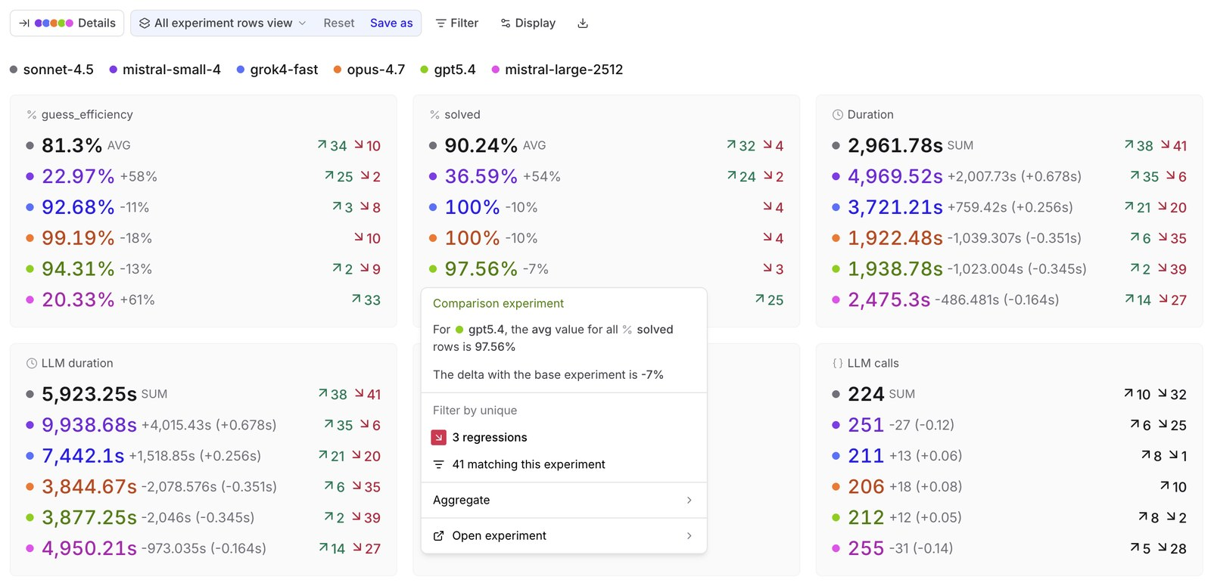
Figure 2. Braintrust experiment comparison across six model runs: per-score averages, deltas and regression counts.
Source: Braintrust docs, Compare experiments
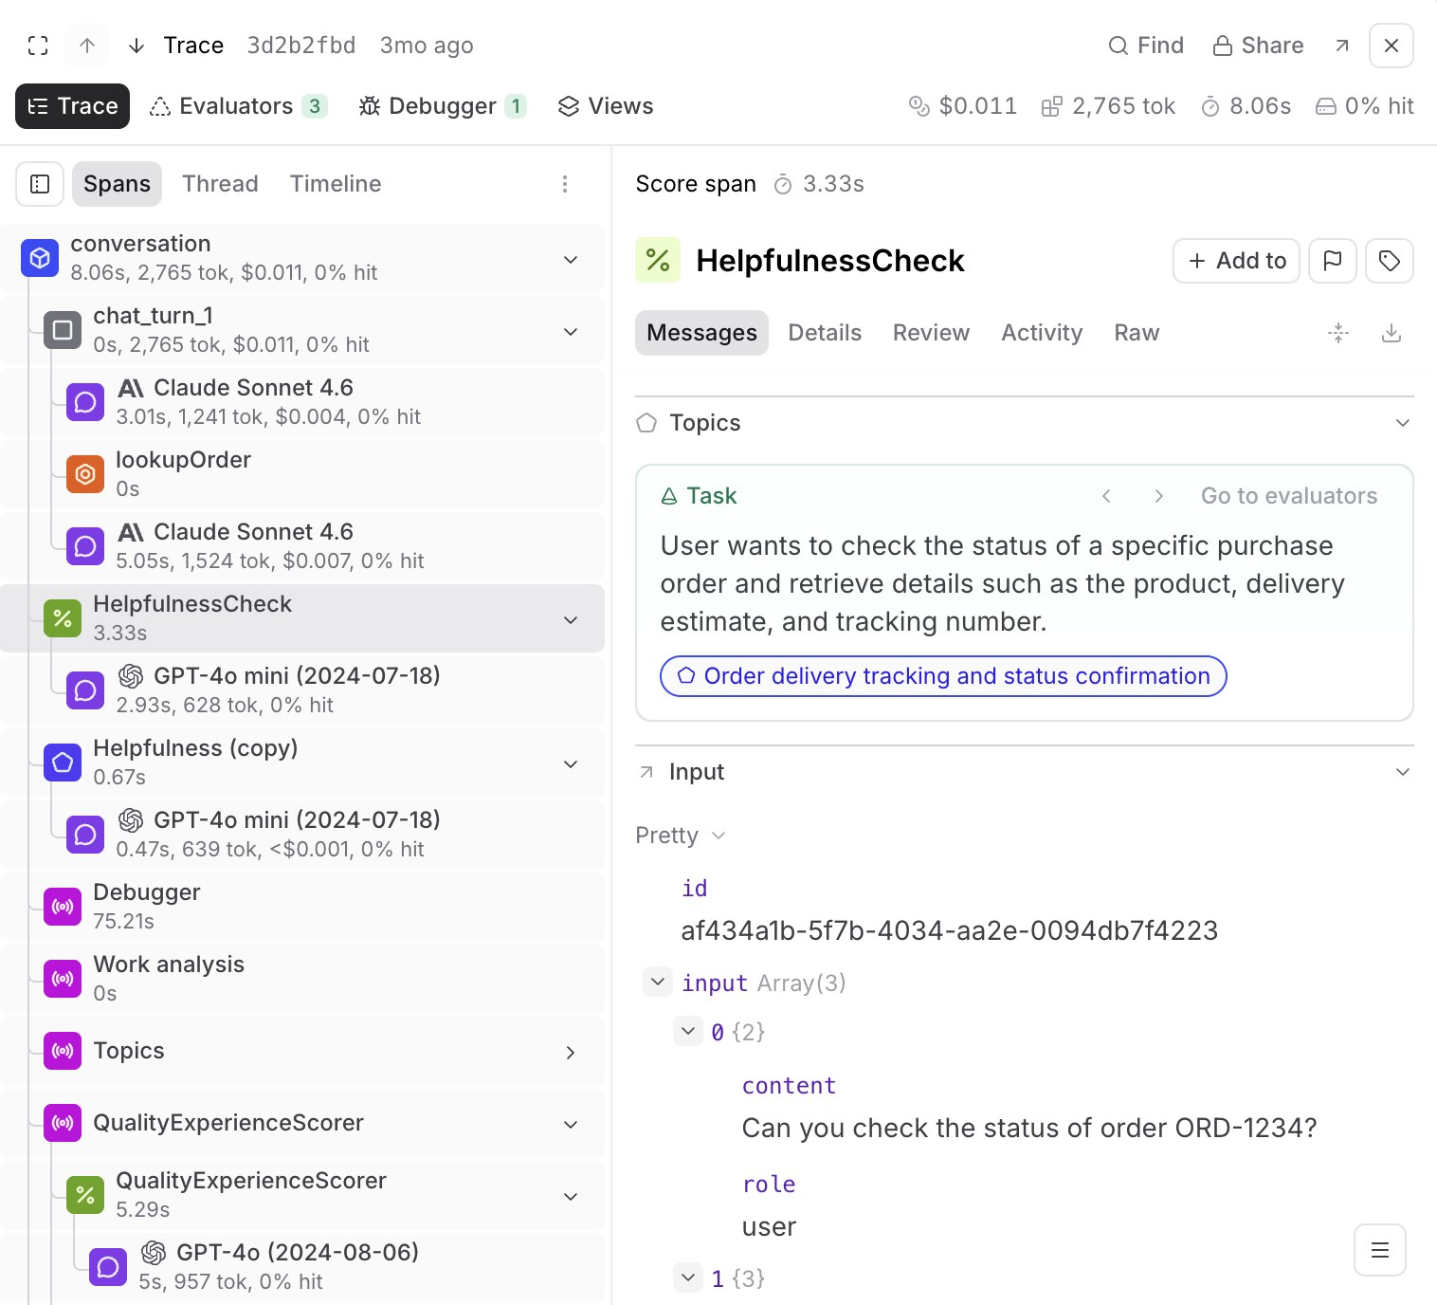
Figure 3. Online scores (HelpfulnessCheck, QualityExperienceScorer) attached as spans inside an agent trace with a tool call.
Source: Braintrust docs, Score online
More Braintrust screenshots are in the appendix.

4.3 Pricing
 | Starter | Pro | Enterprise
Price | $0 | $249 / month | Custom (annual)
Processed data | 1 GB/mo, then $4/GB | 5 GB/mo, then $3/GB | Custom
Scores | 10k/mo, then $2.50 per 1k | 50k/mo, then $1.50 per 1k | Custom
Retention | 14 days | 30 days (to 180 days at extra cost) | Custom
Enterprise-only |  |  | SSO, audit logs, BYOC / self-host, BAA
Users, projects and experiments are unlimited on every plan. Source: braintrust.dev/pricing.

4.4 Advantages
- Most mature offline workflow: Eval(), datasets, playgrounds and a clear experiment diff with regression counts.
- Flexible online scoring at span, trace or session scope with SQL filters and sampling.
- Ready-made GitHub Action posts eval results on every pull request.
- Strong agent support: trace-level scorers, OpenTelemetry ingest, 30+ framework integrations.
- Built-in AI analysis (Loop, Patterns, Topics) helps find failure modes you did not know to test for.
- Broad SDK coverage (TS, Python, Go, Java, Ruby, C#) and a usable free tier with unlimited users.

4.5 Disadvantages
- Closed-source platform; the control plane is always Braintrust-hosted, so no fully air-gapped option.
- Hybrid, self-hosting, SSO, audit logs and BAA are Enterprise-only.
- Metered by GB and by score, so heavy online scoring grows the bill directly.
- Score-threshold CI gating needs custom Reporter code; the Action itself only comments.
- Short default retention (14 / 30 days); some features (Patterns, Sandboxes) still in preview.
- No red-teaming or adversarial testing features.

4.6 When to use it, and when not to
Choose Braintrust when… | Avoid it when…
- You want one SaaS tool for offline evals, PR feedback and production scoring, with little ops work.  - Your team iterates quickly on prompts and models and values side-by-side comparisons.  - You build multi-step or multi-turn agents and need trace and session-level scoring.  - Your stack is polyglot (Go, Java, C#) or already uses OpenTelemetry. | - You need fully open source or fully air-gapped hosting.  - You plan very high-volume online scoring on a tight budget without an Enterprise deal.  - You need built-in red teaming (pair it with a dedicated tool).

5. AWS AgentCore Evaluations
AgentCore Evaluations is the managed evaluation service inside Amazon Bedrock AgentCore. It scores agents at session, trace and tool-call level, using built-in or custom judges, and writes every result into CloudWatch. It became generally available on 31 March 2026.
At a glance
Type | Managed AWS service (part of Amazon Bedrock AgentCore)
Hosting | Your AWS account. Agents can run anywhere (AgentCore Runtime, ECS, EKS, Lambda, off-AWS), but traces must reach CloudWatch via OpenTelemetry (ADOT) with Transaction Search enabled
Entry price | Pay per use: built-in judges per token, custom judges per 1,000 evaluations, plus CloudWatch costs
Frameworks | Strands, LangGraph, OpenAI Agents SDK, Vercel AI SDK, LlamaIndex, Google ADK, Claude Agent SDK; any agent using OTel GenAI or OpenInference conventions
Best at | Managed production monitoring of agents on AWS, tool-level judging

5.1 How evaluation works in AgentCore

Online evaluation
- An evaluation configuration points at an AgentCore agent endpoint or CloudWatch log groups, with up to 25 evaluators, up to 5 filters and a sampling rate from 0.01% to 100% (default 10%).
- Results go to CloudWatch Logs and Metrics; view them under CloudWatch > GenAI Observability, and set CloudWatch alarms on score drops.
- Once a configuration is enabled, the custom evaluators it uses are locked (no edit or delete until it is disabled); you clone to change one.

On-demand, batch and dataset evaluation
- On-demand: a synchronous Evaluate API over chosen spans or traces, aimed at build-time and CI testing.
- Batch: an async job over sessions in CloudWatch (by time range or IDs), supports ground truth; up to 500 sessions per job.
- Datasets (public preview): versioned scenarios with expected responses and assertions; SDK runners invoke the agent and evaluate. User simulation (persona + goal) drives multi-turn tests.

Evaluators
- Built-in judges: Goal success rate (session); Correctness, Faithfulness, Helpfulness, Harmfulness, Coherence, Conciseness, Instruction following, Refusal, Response relevance, Stereotyping (trace); Tool selection and Tool parameter accuracy (tool call); plus two skill evaluators (15 LLM judges in total).
- Three no-LLM trajectory matchers (exact order, in order, any order) against an expected tool path.
- Custom evaluators: your own LLM judge on a Bedrock model, code-based evaluators in AWS Lambda, or a derived version of a built-in. Managed third-party evaluators from DeepEval and AutoEval (for example Toxicity, Bias, PII leakage) are also available; AWS makes no quality claims for them.

CI and human review
- No turnkey CI action: you script the SDK or CLI in your pipeline and gate on thresholds. Telemetry takes 2 to 5 minutes to reach CloudWatch first.
- No built-in human annotation queue or red-teaming module found; safety comes from the Harmfulness, Stereotyping, Refusal and third-party PII/Toxicity evaluators.

5.2 What it looks like
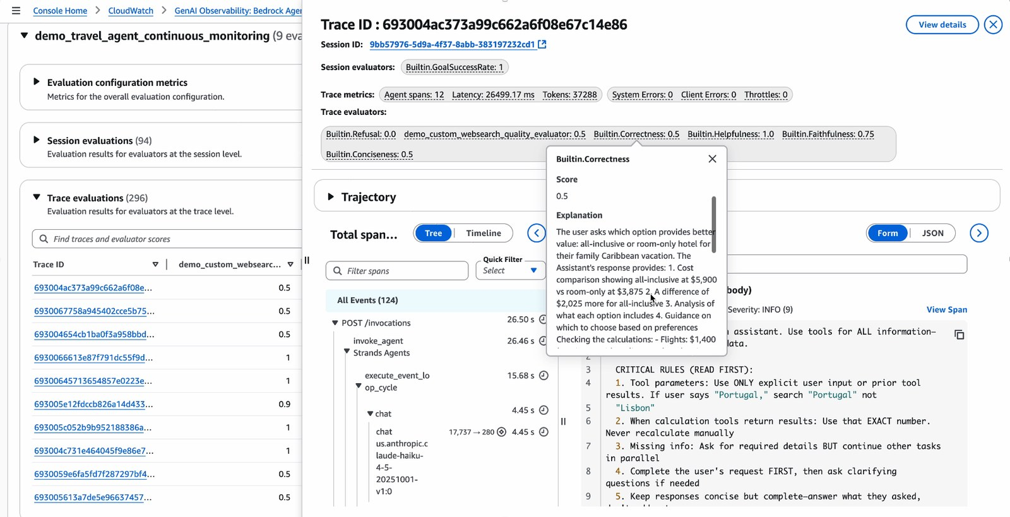
Figure 4. CloudWatch trace view with evaluator scores and the judge's explanation next to the agent's span tree.
Source: AWS ML Blog, Build reliable AI agents with AgentCore Evaluations
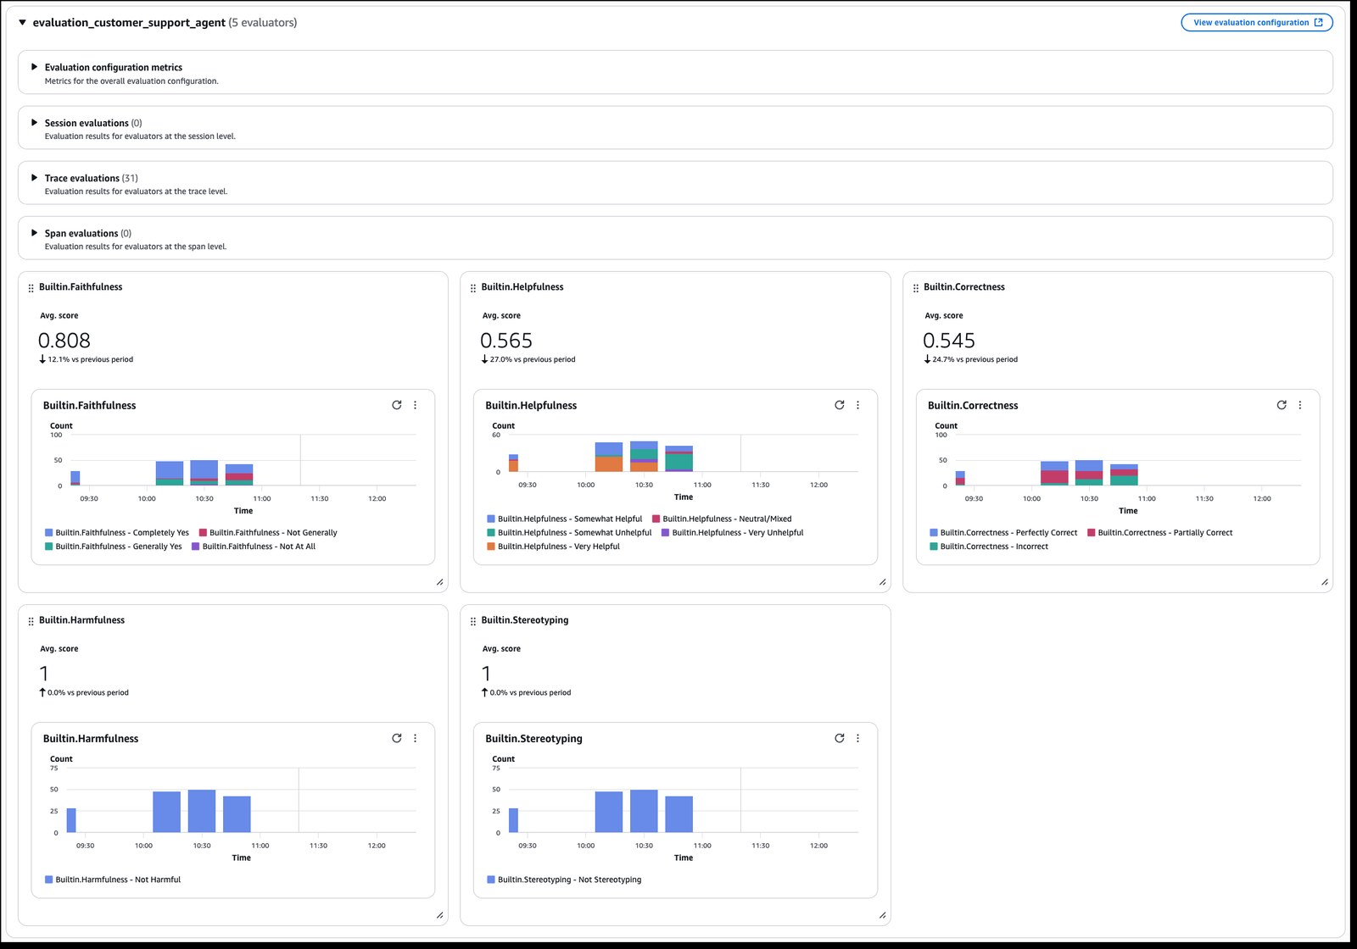
Figure 5. Evaluation results in CloudWatch: session, trace and span sections with average-score tiles and label counts over time.
Source: AWS News Blog, AgentCore quality evaluations
More AgentCore screenshots are in the appendix.

5.3 Pricing
Item | Price
Built-in evaluators | $0.0024 per 1K input tokens; $0.012 per 1K output tokens (judge model included)
Custom evaluators | $1.50 per 1,000 evaluations, plus the judge model's inference in your account
Batch evaluations | 25% lower token rates ($0.0018 / $0.009 per 1K tokens)
Also billed | CloudWatch ingestion and storage; Lambda for code-based evaluators
AWS's own worked example (15,000 interactions, 3 built-in + 1 custom evaluator) comes to about $1,804.50 per month. Source: aws.amazon.com/bedrock/agentcore/pricing. Re-check the live page for your region before budgeting.

5.4 Advantages
- Fully managed: no judge infrastructure to run, and built-in judge model costs are included in the token price.
- One set of evaluators covers development (on-demand), regression (batch / datasets) and production (online).
- Scores sessions, traces and individual tool calls, including tool selection and argument accuracy, plus deterministic trajectory matching.
- Flexible custom evaluators: LLM judge on any Bedrock model, Lambda code, or derived built-ins.
- Open telemetry standards (OTel GenAI, OpenInference) and broad framework support; agents need not run on AgentCore.
- Native CloudWatch alarms, dashboards and judge reasoning inside the trace view; data stays in your AWS account and region.

5.5 Disadvantages
- Requires AWS: every trace must land in CloudWatch in your account, which adds CloudWatch cost and lock-in.
- No built-in human annotation queue and no red-teaming module.
- Datasets and simulation are still in preview; the experiment-comparison experience is thinner than Braintrust or Langfuse.
- Token-metered built-in judges get expensive at volume.
- Operational friction: locked evaluators, 2 to 5 minute ingestion lag, 1 evaluator per on-demand call, 500 sessions per batch job.
- Judges are limited to Bedrock models, and built-in judge prompts cannot be edited.

5.6 When to use it, and when not to
Choose AgentCore when… | Avoid it when…
- Your agents run on AWS and CloudWatch is already your observability standard.  - You need always-on production quality monitoring with sampling and alarms more than an experiment lab.  - Tool-heavy or multi-turn agents need tool-call and trajectory-level scoring.  - Data must stay inside your AWS account and region (IAM, KMS, GovCloud). | - You are multi-cloud or cannot route traces into CloudWatch.  - You need human labelling workflows, rich dataset and experiment UIs, or red teaming out of the box.  - You need judge models outside Bedrock.

6. Langfuse
Langfuse is an open-source (MIT) LLM engineering platform for tracing, prompt management, evaluation and metrics. You can self-host it for free or use Langfuse Cloud. ClickHouse, Inc. acquired Langfuse in January 2026 and says licensing and self-hosting will not change.
At a glance
Type | Open source (MIT, except ee/ folders); company owned by ClickHouse, Inc. since 16 Jan 2026
Hosting | Langfuse Cloud (EU, US, Japan, HIPAA regions) or self-hosted: web + worker containers, Postgres, ClickHouse, Redis, S3 (Helm for production)
Entry price | Self-host free; Cloud Hobby free, Core $29/month, Pro $199/month
Integrations | OpenTelemetry-based; about 50 frameworks incl. LangChain/LangGraph, LlamaIndex, OpenAI Agents, Vercel AI SDK, LiteLLM, CrewAI, Strands, AgentCore
Best at | Open, self-hostable tracing + evals, PR regression gates, low cost

6.1 How evaluation works in Langfuse

Offline: datasets and experiments
- Versioned datasets; items can be created straight from production traces.
- Experiments run via the SDK (with concurrency) or in the UI ("Prompt Experiments") with LLM-judge or code evaluators; results compare side by side against a baseline.
- Prompt management with versions and labels, and a playground for side-by-side variants.

Online: LLM-as-judge on production traces
- Evaluator "rules" with filters (type, name, metadata, user, session, tags, version) and a sampling rate run judges on live observations.
- Numeric, categorical or boolean scores; multi-modal judges; code evaluators (Python / TypeScript) on all plans.
- Custom scores can be pushed via API from your own pipelines. Langfuse estimates $0.01 to $0.10 per judgment in model cost.

CI: release gates
- Official langfuse/experiment-action GitHub Action: your script raises RegressionError when a score breaks its threshold and the job fails (default on). Results are posted as a PR comment.

Agents
- Agent graphs drawn from traces (aggregated or expanded view); sessions group multi-turn conversations.
- Gap: each automated evaluator sees one observation (span) only. Until 16 Nov 2026, Langfuse Cloud judges can still score a whole trace's input and output; after that, only single observations. New adopters should build on observation-level judges from day one. Multi-span, session and trajectory evaluations are on the roadmap (in progress). Simulation exists only as a cookbook.

Human review
- Annotation queues for traces, observations or sessions, with score configs, assignment, keyboard workflow, corrected outputs, and judge calibration against human labels.
- End-user feedback (thumbs up/down) captured as scores.

6.2 What it looks like
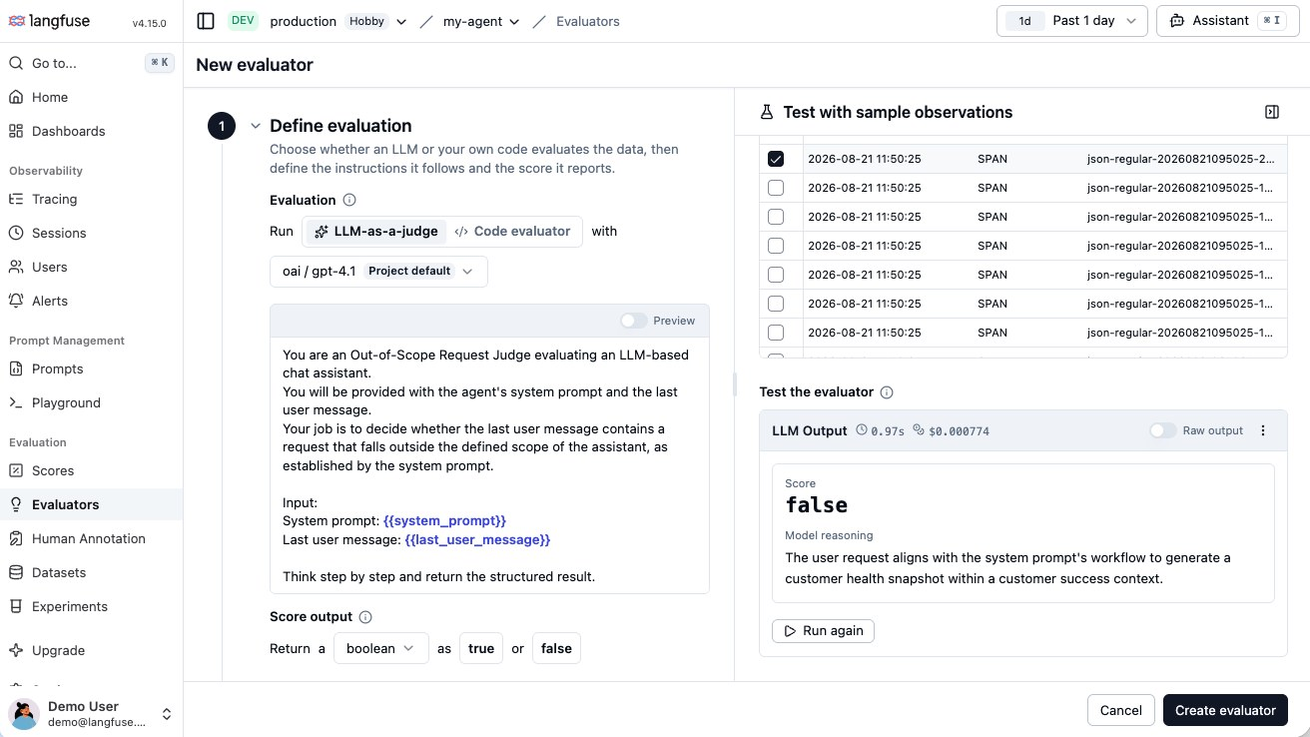
Figure 6. Setting up an LLM-as-judge evaluator, tested on sample observations with the judge's reasoning shown.
Source: Langfuse docs, LLM-as-a-judge
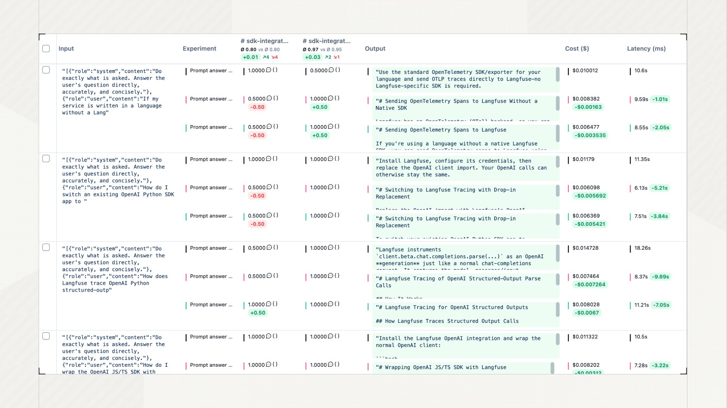
Figure 7. Comparing experiment runs item by item against a baseline, with score, cost and latency deltas.
Source: Langfuse docs, Compare experiments
More Langfuse screenshots are in the appendix.

6.3 Pricing
Plan | Price | Includes
Self-hosted (OSS) | Free | All core features incl. judges, datasets, experiments, annotation queues; you run the infrastructure
Cloud Hobby | Free | 50k units / month, 30 days data access, 2 users
Cloud Core | $29 / month | 100k units, 90 days data access
Cloud Pro | $199 / month | 3 years data, SOC 2 / ISO reports, HIPAA BAA; Teams add-on +$300/month for SSO and RBAC
Enterprise | $2,499 / month (Cloud); custom for self-host | Audit logs, SCIM, SLAs; self-host Enterprise bundled with a ClickHouse commercial plan
Overage is $8 per 100k units, falling to $6 per 100k above 50M. Sources: langfuse.com/pricing and langfuse.com/pricing-self-host.

6.4 Advantages
- MIT licence: the free self-hosted version includes LLM-as-judge, code evaluators, datasets, experiments, annotation queues and prompt management.
- Built on OpenTelemetry with the widest set of integrations (about 50 frameworks plus gateways).
- Official GitHub Action fails PR builds on regressions and comments results.
- Traces, datasets, experiments and scores share one data model, so trace → dataset → experiment → CI is tight.
- Online judges with filters, sampling, API management and calibration against human labels.
- Cheapest hosted entry ($0 / $29 / $199) with EU, US, Japan and HIPAA regions.

6.5 Disadvantages
- No automated trajectory, multi-span or session evaluation yet: each judge sees one observation.
- No native simulation or red teaming.
- Self-hosting is a real operations load (four stateful stores; ClickHouse 25.12+), and official ClickHouse support now points to ClickHouse's paid offerings.
- v4 is a breaking migration: old SDKs, legacy APIs and trace-level judges stop working (Cloud trace-level judges end 16 Nov 2026).
- SSO and RBAC cost +$300/month on Pro; audit logs and SCIM need Enterprise.

6.6 When to use it, and when not to
Choose Langfuse when… | Avoid it when…
- You need self-hosting or strict data residency without paying a licence for evaluation features.  - You want open-source tracing + evals with OpenTelemetry and broad framework coverage.  - You want PR-level regression gates on datasets via GitHub Actions.  - Budget is limited or trace volume is high. | - You need first-class trajectory or multi-turn agent scoring, simulation or red teaming today.  - You cannot run ClickHouse, Postgres, Redis and S3 yourself and also cannot use the cloud.  - You need audit logs or SCIM without an Enterprise budget.

7. Arize AX
Arize AX is Arize AI's managed platform for tracing, evaluating and improving AI agents. It is built on OpenTelemetry and OpenInference (which Arize created). Its source-available sibling, Arize Phoenix, is free to self-host under the Elastic License 2.0 (ELv2).
At a glance
Type | Commercial, closed-source platform (AX); Phoenix is source-available under ELv2
Hosting | Free and Pro: SaaS (US, EU or Canada regions). Enterprise: SaaS or self-hosted on any Kubernetes, incl. air-gapped; PrivateLink options
Entry price | AX Free $0; AX Pro $50/month; Enterprise custom
Integrations | OTel / OpenInference auto-instrumentation for 30+ frameworks: LangChain, LangGraph, LlamaIndex, CrewAI, OpenAI Agents, Claude Agent SDK, Google ADK, DSPy, Mastra, Strands, MCP
Best at | Agent path views, governed reusable judges, judge calibration

7.1 How evaluation works in Arize AX

Offline: datasets and experiments
- Versioned datasets; experiments run from code (Python, TypeScript, CLI, REST), the prompt playground, an Agent Playground against your endpoint, or a coding agent.
- "Compare Experiments" shows per-row diffs and evaluator deltas; Prompt Hub stores versioned prompts with tags.

Online: evaluator tasks
- An evaluator is attached to a task with a filter, a sampling rate and a cadence (continuous, historical backfill, or both); Arize handles retries and rate limits.
- Monitors watch any span attribute, including eval labels, and alert to Slack, PagerDuty, OpsGenie or Teams.
- Arize itself notes online evals are bounded by what the UI exposes; complex pipelines are better run offline with phoenix.evals.

Evaluators and judge governance
- Five evaluator types: LLM-as-judge, decision judge, code (pre-built code templates on all plans; custom code evaluators on Enterprise only), agent-as-judge (a Claude Code harness that reads traces itself) and remote (your endpoint), at span, trace or session scope.
- Evaluator Hub: reusable, versioned judges with commit messages, shared across projects. About 28 pre-built templates incl. Tool Calling, Task Completion, Step Efficiency, Hallucination, PII, Prompt Injection, Jailbreak.
- Judge calibration: compare judge labels with human labels; the Alyx assistant iterates until agreement is acceptable and saves a new version.

CI, agents and human review
- CI gating is scripted: an experiment script exits non-zero below a threshold; guides exist for GitHub Actions, GitLab, Azure DevOps, Jenkins and Harness.
- Agent Graph and Agent Path views (automatic for LangGraph, AutoGen, CrewAI, OpenAI Agents, Agno).
- Labelling queues and annotation configs on all plans. Guardrails and red teaming are recipes (Guardrails AI library, notebooks), not managed features.

7.2 What it looks like
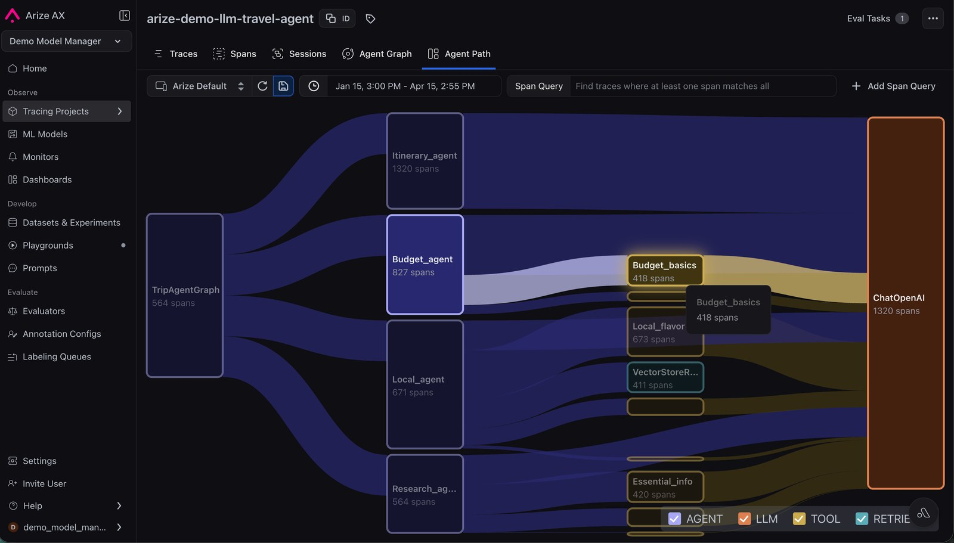
Figure 8. Agent Path view: how requests flow from the orchestrator through sub-agents and tools, with span counts.
Source: Arize docs, Agent trajectory
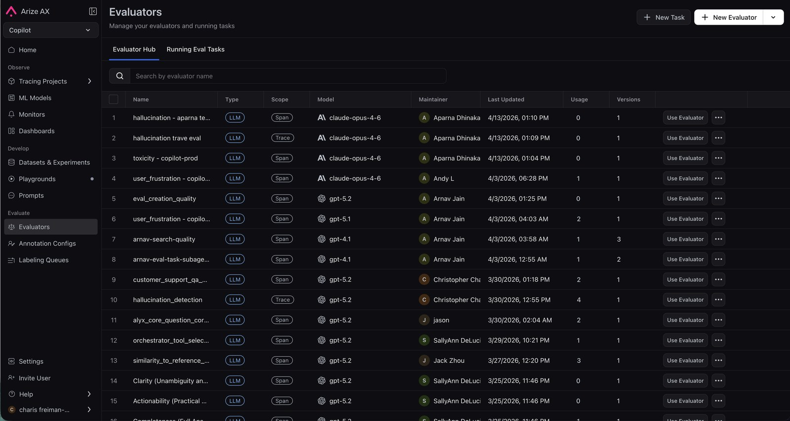
Figure 9. Evaluator Hub: versioned, reusable judges with scope, judge model, usage and version history.
Source: Arize docs, Create evaluators
More Arize AX screenshots are in the appendix.

7.3 Pricing
 | AX Free | AX Pro | AX Enterprise
Price | $0 | $50 / month | Custom
Spans / month | 25k | 50k | Custom
Storage | 1 GB | 10 GB | Custom
Retention | 15 days | 30 days | Custom
Enterprise-only |  |  | Self-host, SSO, audit logs, HIPAA, custom code evaluators, Data Fabric
All plans include unlimited users, online evals, experiments, datasets, annotations and Alyx. No per-span overage rate is published. Source: arize.com/pricing.

7.4 Advantages
- One managed platform: tracing, issue detection, online and offline evals, experiments, prompt hub, annotation, monitors.
- Standards-based (OTel / OpenInference): no proprietary trace format, easy to move instrumentation.
- Strongest evaluator governance: versioned Evaluator Hub, reusable judges, about 28 templates, calibration against human labels.
- Strong agent features: Agent Graph / Path, trajectory and session templates, agent-as-judge.
- Free tier is generous on features (unlimited online evals, users, annotations).
- Flexible Enterprise hosting: self-hosted or air-gapped Kubernetes, PrivateLink, US/EU/CA regions, HIPAA, PCI.

7.5 Disadvantages
- Closed source; custom code evaluators, SSO, self-hosting and audit logs are Enterprise-only.
- Small span allowances and short retention on Free and Pro (25k / 50k spans, 15 / 30 days).
- CI gating is do-it-yourself scripting; guardrails and red teaming are recipes, not product features.
- Reviewers report a steep learning curve; its ML-monitoring heritage is still visible in the UI.
- You pay the judge-model cost through your own AI provider.

7.6 When to use it, and when not to
Choose Arize AX when… | Avoid it when…
- You run multi-agent systems in production and need trajectory views plus continuous trace and session evals.  - Many teams should share one versioned, calibrated library of judges.  - You are a regulated enterprise needing self-hosted or air-gapped deployment and have Enterprise budget.  - You want to start free on Phoenix and graduate to a managed platform later. | - You need custom code evaluators or self-hosting on a small budget.  - You have high trace volume but only a Pro budget.  - You want a turnkey CI release gate or managed red teaming.

8. Side-by-side comparison
Documented capabilities as of 19 October 2026. Every cell starts with a word, and the colour repeats it: Yes = built in (green); Partial = works but needs your own code, is limited, or is in preview; Paid tier = Enterprise or a paid add-on only (both amber); No = not found in the vendor's docs (red).
 | Braintrust | AWS AgentCore | Langfuse | Arize AX
Source model | Closed platform; MIT SDKs | AWS managed service | Open source (MIT) | Closed (AX); Phoenix source-available (ELv2)
Self-host | Paid tier: Enterprise, data plane only (UI stays with Braintrust) | Partial: managed by AWS, data in your AWS account | Yes, free | Paid tier: Enterprise, full, incl. air-gapped
Datasets and experiments | Yes, most mature UI | Partial: datasets in preview; batch jobs GA | Yes | Yes
Online scoring with sampling | Yes | Yes (0.01% to 100%) | Yes | Yes
CI release gate | Partial: Action posts PR comment; failing the build needs a short script | Partial: script the SDK / CLI | Yes: Action fails the build | Partial: script (exit code)
Agent trajectory / session judging | Yes (trace and session scorers) | Yes (session, trace, tool call, path matchers) | Partial: one observation per judge | Yes (trace, session, agent-as-judge)
Built-in judge templates | Yes (autoevals) | Yes (15 judges + 3 path matchers) | Yes (template library + your own) | Yes (about 28)
Custom code evaluators | Yes | Yes (Lambda) | Yes | Paid tier: Enterprise
Human annotation queues | Yes | No (none found) | Yes | Yes
Judge calibration vs humans | Partial (manual) | No (none built in) | Yes | Yes (with Alyx)
Simulation | No (none found) | Partial: preview (user simulation) | No (cookbook only) | No (none found)
Red teaming | No (none found) | Partial: safety judges only | No (none found) | Partial: recipes + guardrails library
OpenTelemetry ingest | Yes | Yes (to CloudWatch) | Yes | Yes (OpenInference)
Free tier | Yes: 10k scores, 14 days | No (pay per use) | Yes: 50k units, 30 days | Yes: 25k spans, 15 days
Setup effort and skills | SDK + API key, any major language | ADOT/OTel to CloudWatch + Transaction Search; AWS and IAM skills | Cloud: SDK + API key. Self-host: Kubernetes/Helm, 4 data stores | SDK + API key; reviewers report a steep learning curve
Pricing model | Per GB + per score | Per token + per evaluation | Per unit (or free self-host) | Per plan + span limits

8.1 Security and compliance
What risk, compliance and security reviewers usually ask for, and which plan provides it:
 | Braintrust | AWS AgentCore | Langfuse | Arize AX
SSO / access control | Paid tier: Enterprise (SAML / OIDC) | Yes: your AWS IAM / IAM Identity Center | Paid tier: Cloud Pro + Teams add-on ($300/mo) | Paid tier: Enterprise
Audit logs | Paid tier: Enterprise | Yes: AWS CloudTrail (API calls) | Paid tier: Enterprise | Paid tier: Enterprise
Compliance reports | SOC 2 Type II; HIPAA BAA on Enterprise | Inherits your AWS account controls (IAM, KMS); check AWS's compliance list for AgentCore | SOC 2 / ISO reports and HIPAA BAA on Pro | SOC 2 and GDPR from Pro; HIPAA on Enterprise; PCI DSS 4.0
Data regions | Not stated; data plane in your cloud on Enterprise | 22 AWS regions, incl. GovCloud (US-West) | EU, US, Japan, HIPAA (US); or self-host anywhere | US, EU, Canada; self-host anywhere on Enterprise
Data retention | 14 days (Starter); 30 to 180 days (Pro); custom | You set it (CloudWatch Logs retention) | 30 days (Hobby); 90 days (Core); 3 years (Pro); self-host: you decide | 15 days (Free); 30 days (Pro); custom

8.2 Team ratings on the four must-haves
These are the team's own capability ratings (3 = strong, 2 = partial, 1 = weak), shown for the four must-have capabilities only:
Capability | Braintrust | AWS AgentCore | Langfuse | Arize AX
Test sets | 3 · Strong | 3 · Strong | 3 · Strong | 3 · Strong
Release gates | 3 · Strong | 2 · Partial | 3 · Strong | 2 · Partial
Agent steps | 2 · Partial | 3 · Strong | 1 · Weak | 3 · Strong
Live scoring | 3 · Strong | 3 · Strong | 3 · Strong | 3 · Strong

Where the research in this guide differs from those ratings:
- Release gates, Braintrust (rated 3): its GitHub Action posts results on the PR, but failing the build on a score drop needs a short script, as with AgentCore and Arize AX. Only Langfuse fails the build out of the box.
- Agent steps, Braintrust (rated 2): its trace-level scorers can read every span and the whole conversation; what it lacks next to AgentCore and Arize AX is built-in path matchers and an agent graph view.
- Test sets, AgentCore (rated 3): batch evaluation is GA, but managed datasets are still in preview.
The overall picture still holds: release gates favour Langfuse; agent steps favour AgentCore and Arize AX, with Braintrust close behind; test sets and live scoring do not separate the tools.

8.3 Cost at a realistic volume
Each vendor bills a different unit, so the tables price one example workload. Change the inputs to match your own traffic.
Assumption | Value
Traffic | 100,000 traces per month, about 8 spans each (800,000 spans), about 20 KB per trace (2 GB per month)
Online scoring | 10% of traces scored by 2 LLM judges = 20,000 judgments per month
Judge size | About 5,000 input and 300 output tokens per judgment
Judge model on your own provider | $0.0065 to $0.0195 per judgment (small vs mid-size model at $1 to $3 per million input and $5 to $15 per million output tokens) = $130 to $390 per month

Tool and plan | Platform fee | Judge-model cost | Other costs | Estimated total / month
Braintrust Pro | $249 (2 GB and 20k scores fit in Pro's 5 GB and 50k) | $130 to $390 (your provider keys or Braintrust credits) | None at this volume | About $380 to $640
AWS AgentCore | None (pay per use) | About $312 with built-in judges, model included | CloudWatch ingestion and storage (depends on region) | About $312 + CloudWatch
Langfuse Cloud Core / Pro | $29 / $199 + $66 overage (920k units: traces + spans + scores; 100k included; $8 per 100k) | $130 to $390 | Teams add-on $300 if SSO is needed | About $225 to $485 (Core); $395 to $655 (Pro)
Langfuse self-hosted | $0 | $130 to $390 | Postgres, ClickHouse, Redis, S3 hosting and the people who run them | Judge cost + infrastructure
Arize AX | 800k spans is above Pro's 50k per month, so Enterprise pricing applies | $130 to $390 | Not published | Quote required

- Arize AX Free / Pro fit only about 3,000 / 6,000 traces a month at 8 spans each.
- AWS's own example (15,000 interactions, 3 built-in + 1 custom evaluator, much larger judge inputs) comes to about $1,804.50 per month. Cost grows with judge input size, so measure your real trace size before budgeting.
- Judge-model tokens dominate at scale for every tool. Sampling (5 to 10% of traffic) and cheap code checks before LLM judges are the main ways to control spend.

9. Decision guide
Answer three questions in order. The first two are constraints (where the tool and the data may live); the third is a preference.
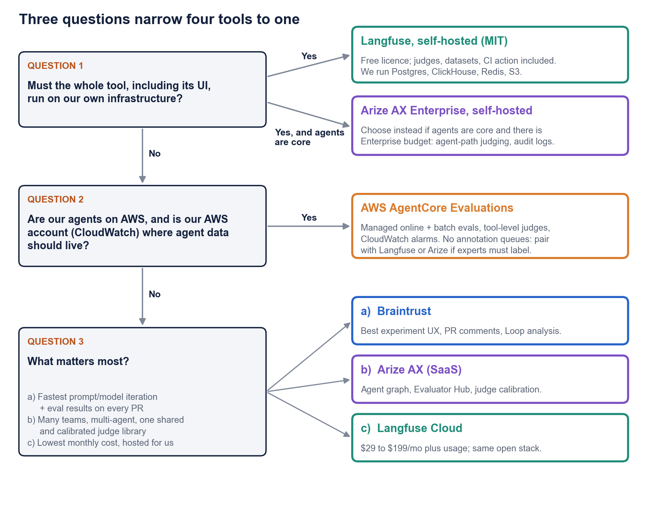
Figure 10. Tool selection flow. Hosting and cloud constraints come first; priorities decide the rest.

9.1 Questions to settle before choosing
- Data residency: may production prompts and outputs leave our network? If not, may they leave our cloud account?
- Cloud: are our agents on AWS, and should agent data live in our AWS account (CloudWatch)?
- Operations: do we have people to run Postgres, ClickHouse, Redis and S3 if we self-host?
- Agents: how much of our risk is in the agent's path (tools, hand-offs) rather than the final answer?
- CI: do we want the build to fail automatically on a score drop, or is a PR comment enough?
- Human review: who labels data (developers, domain experts, compliance), and how many per week?
- Judge governance: do several teams need to share and version the same judges?
- Volume: how many traces per month, and what share will we score online? (See section 8.3.)
- Compliance: do we need SSO, audit logs, a HIPAA BAA or specific data regions? (See section 8.1.)
- Budget and procurement: SaaS subscription, Enterprise contract, AWS spend, or no licence at all?

9.2 Common scenarios
This is the single list of recommendations; the summary and the flow above give the same picks.
Scenario | Pick | Runner-up and tie-break
The whole tool must run on our own infrastructure; no licence fee | Langfuse self-hosted | Arize AX Enterprise self-hosted if agents are core and you need audit logs and agent-path judging now.
Regulated (bank, healthcare), self-hosted, agents are core, Enterprise budget | Arize AX Enterprise self-hosted | Langfuse self-hosted with an Enterprise licence (audit logs) if agent-path judging can wait for its roadmap.
Agents on AWS; agent data should stay in our AWS account | AWS AgentCore Evaluations | Add Langfuse or Arize AX if domain experts must label outputs. If CloudWatch is not mandatory and many teams must share judges, choose Arize AX.
Fast prompt and model iteration; eval results on every PR; SaaS fine | Braintrust | Langfuse Cloud if the build must fail with no extra code, or if budget is tight.
Many teams building multi-agent systems; one shared, calibrated judge library | Arize AX (SaaS; Enterprise at scale) | Braintrust.
Lowest monthly cost, hosted for us (for example a startup) | Langfuse Cloud | Braintrust if its experiment workflow is worth about $150 to $250 more per month; Langfuse self-hosted at very high volume.

Tip: keep your evaluation assets portable
All four tools accept OpenTelemetry traces (AgentCore through CloudWatch, Arize through OpenInference), so instrumentation moves with you.
Datasets, judge prompts, scorer code, human labels and CI scripts do not move between tools. Keep golden datasets and judge rubrics in your own repository (JSON or YAML) so a later switch costs days, not months.

10. Sources and caveats
All facts were checked against these vendor pages on 19 October 2026. Screenshots are taken from the vendors' own documentation and blog posts and are credited under each figure.

Braintrust
- Pricing
- Plans and limits
- Run evals in code
- Score online
- Run in CI
- Custom code scorers
- Deployment options
- Human review
- Loop

AWS AgentCore
- GA announcement
- How evaluations work
- Create online evaluations
- Batch evaluations
- Dataset evaluations (preview)
- Built-in evaluators
- Supported frameworks
- Quotas
- Pricing

Langfuse
- Joining ClickHouse
- Pricing
- Self-host pricing
- LLM-as-a-judge
- Experiments in CI/CD
- experiment-action
- Annotation queues
- Self-hosting
- Roadmap

Arize AX
- AX docs
- Pricing
- Create evaluators
- Online vs offline evals
- Align evals to human feedback
- CI/CD experiments
- Agent trajectory
- Self-hosted
- Phoenix licence

Caveats
- Prices, plan limits and preview features change often. Re-check the pricing pages before budgeting.
- AgentCore pricing was read without a region; confirm on the live page for your region.
- "None found" means the vendor documentation showed no such feature, not that the vendor has said it does not exist.
- The team capability ratings in section 8.1 are the team's own judgement, not vendor claims.

Appendix: more screenshots
Further product screenshots for each tool, from the vendors' own documentation.

Braintrust
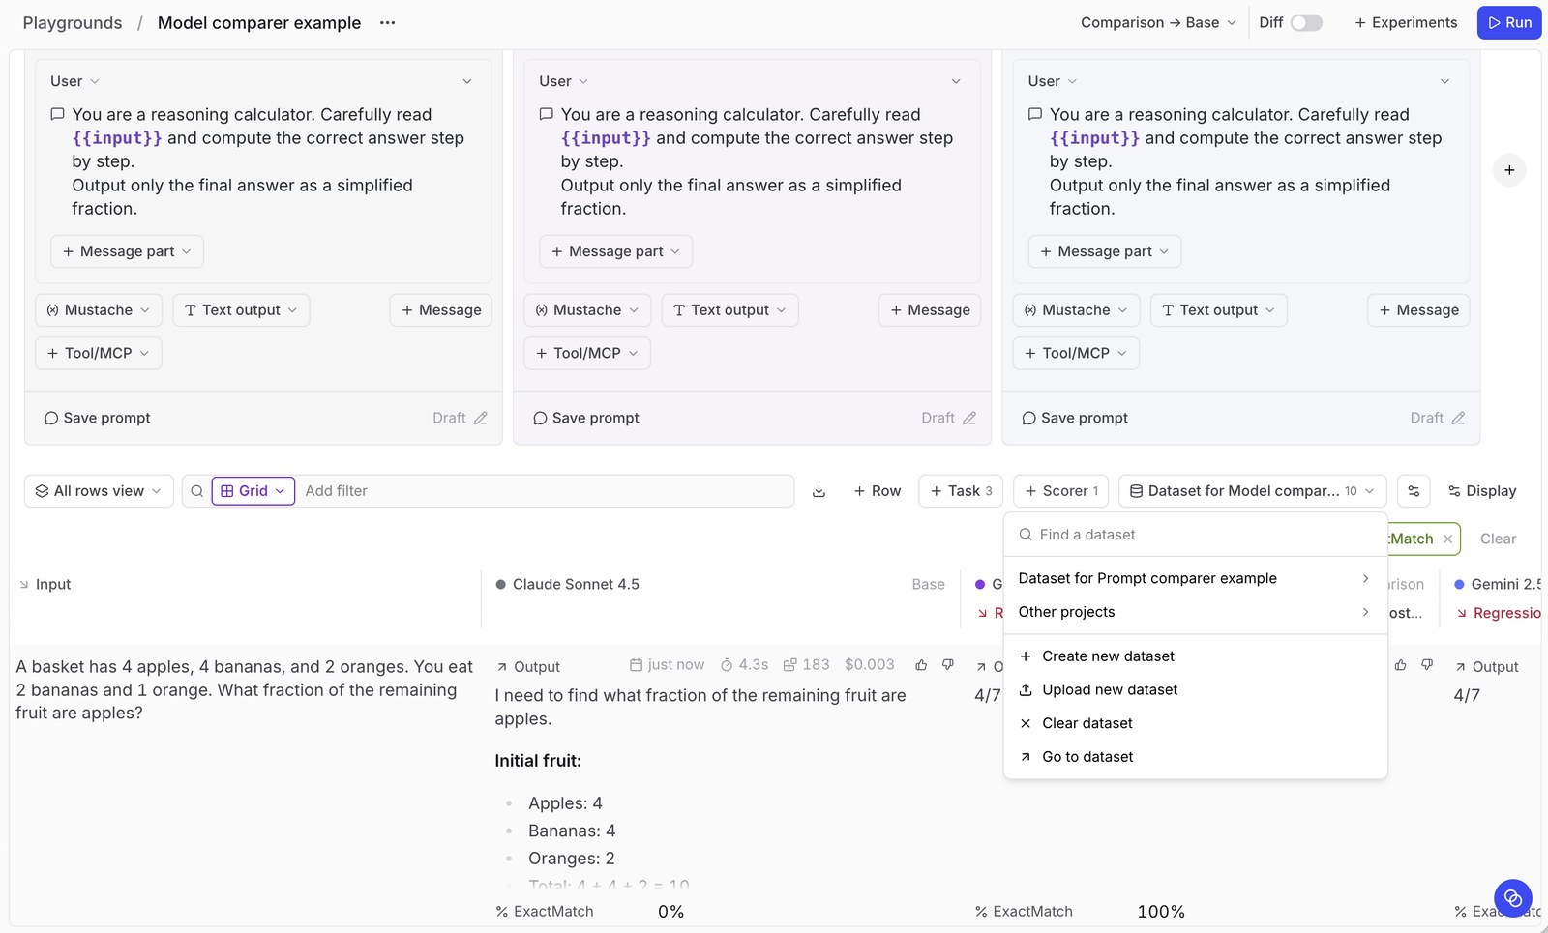
Figure 11. Playground comparing three prompt variants on a dataset, scored with ExactMatch and flagged for regression.
Source: Braintrust docs, Remote evals
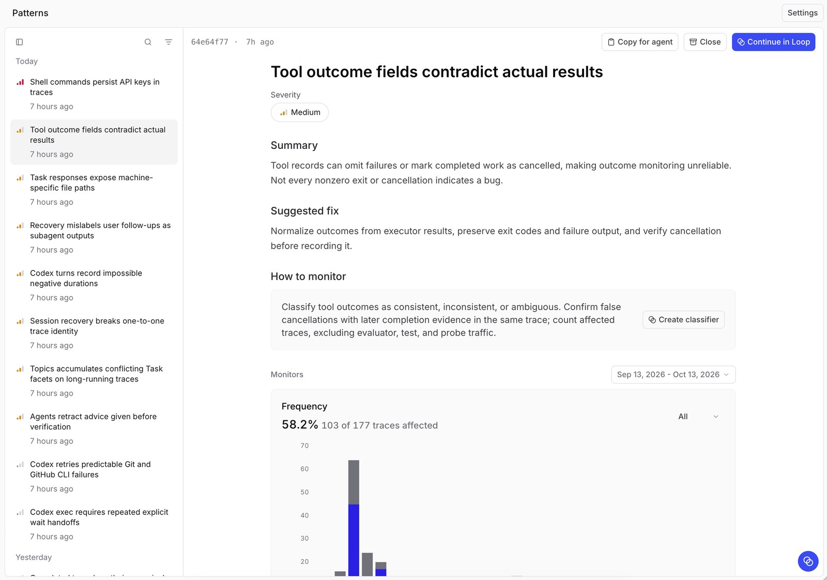
Figure 12. Patterns view (powered by Loop): a recurring issue found automatically, with severity, suggested fix and frequency.
Source: Braintrust docs, Patterns

AWS AgentCore
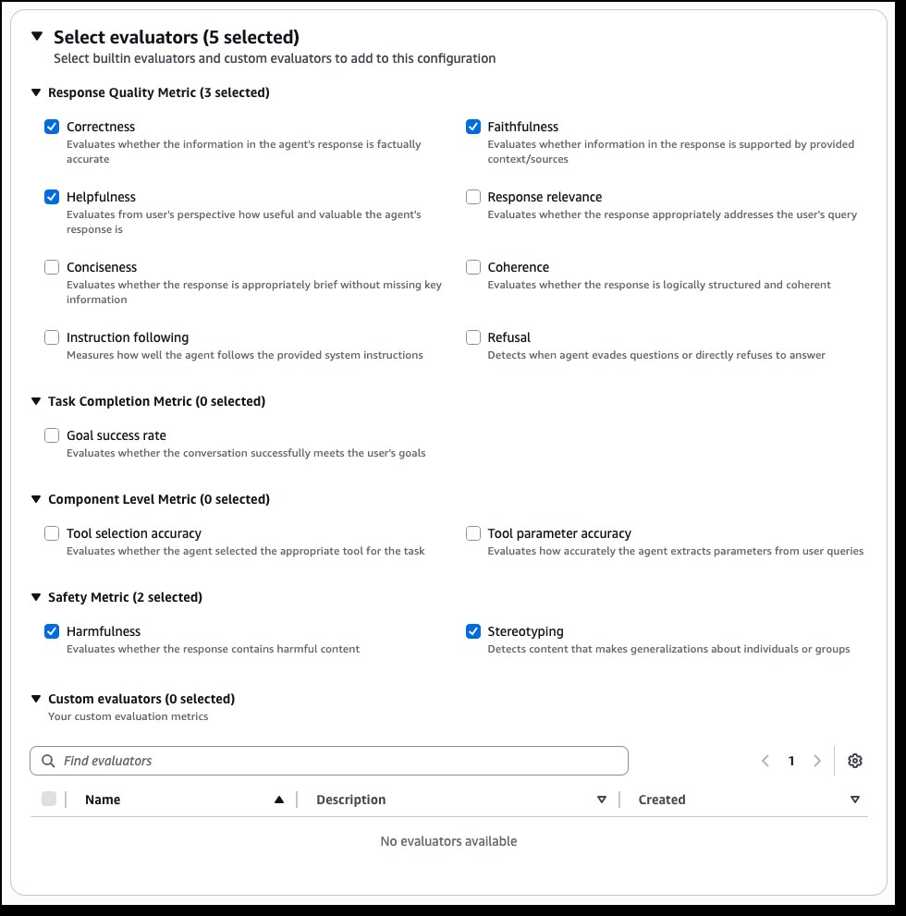
Figure 13. Creating an online evaluation in the AgentCore console: choosing built-in evaluators by category.
Source: AWS News Blog, AgentCore quality evaluations
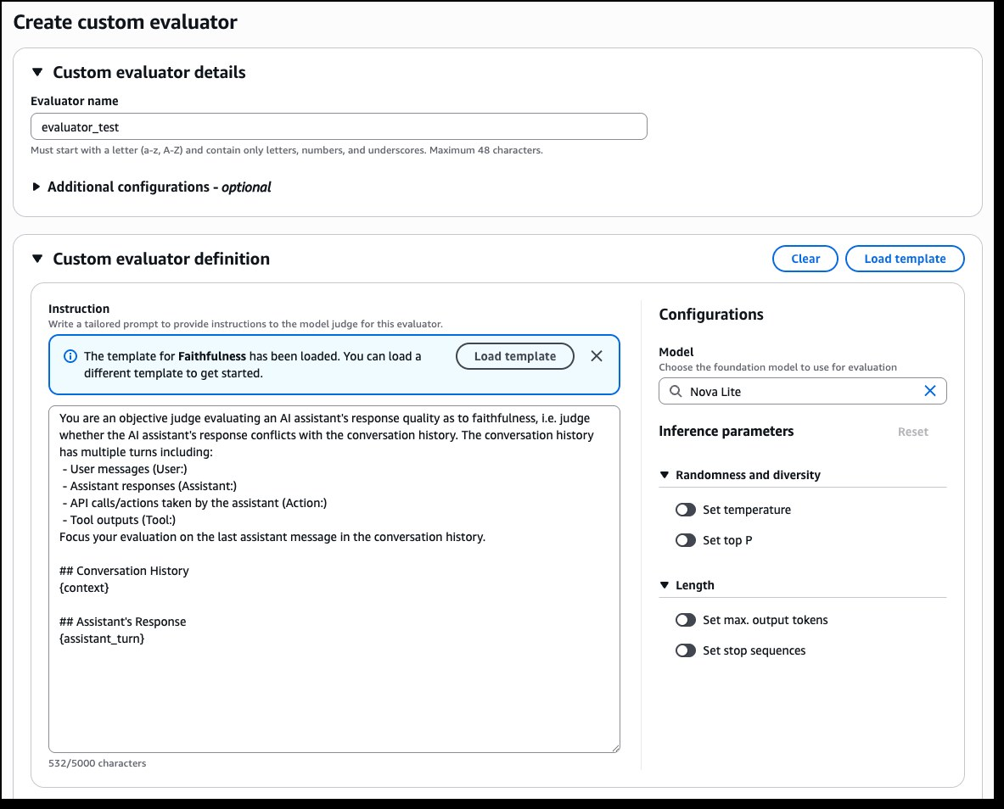
Figure 14. Creating a custom LLM-as-judge evaluator: rubric instructions with placeholders and the judge model settings.
Source: AWS News Blog, AgentCore quality evaluations

Langfuse
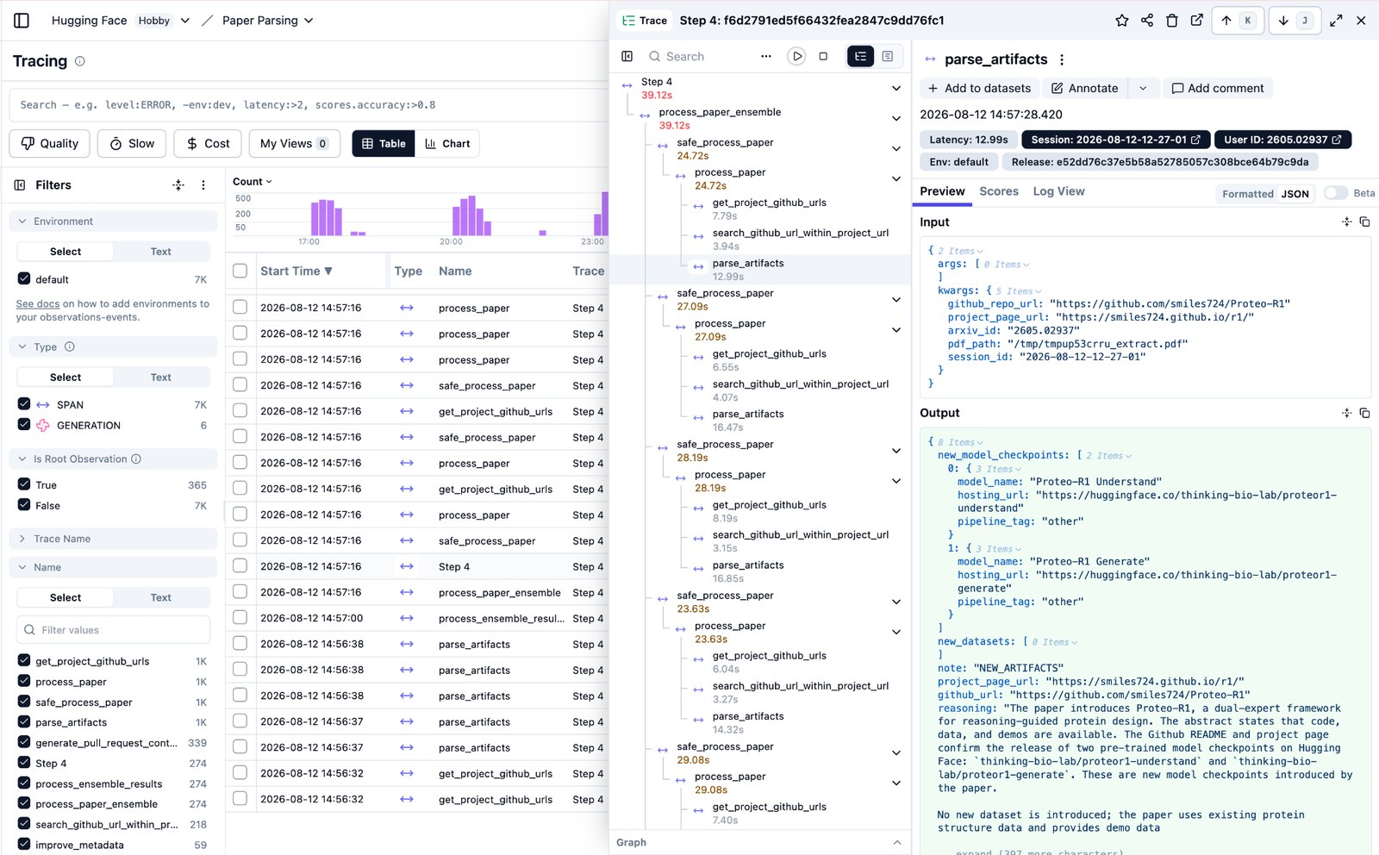
Figure 15. Langfuse tracing: filterable trace table with a nested span tree, inputs/outputs and Add to dataset / Annotate actions.
Source: Langfuse docs, Observability overview
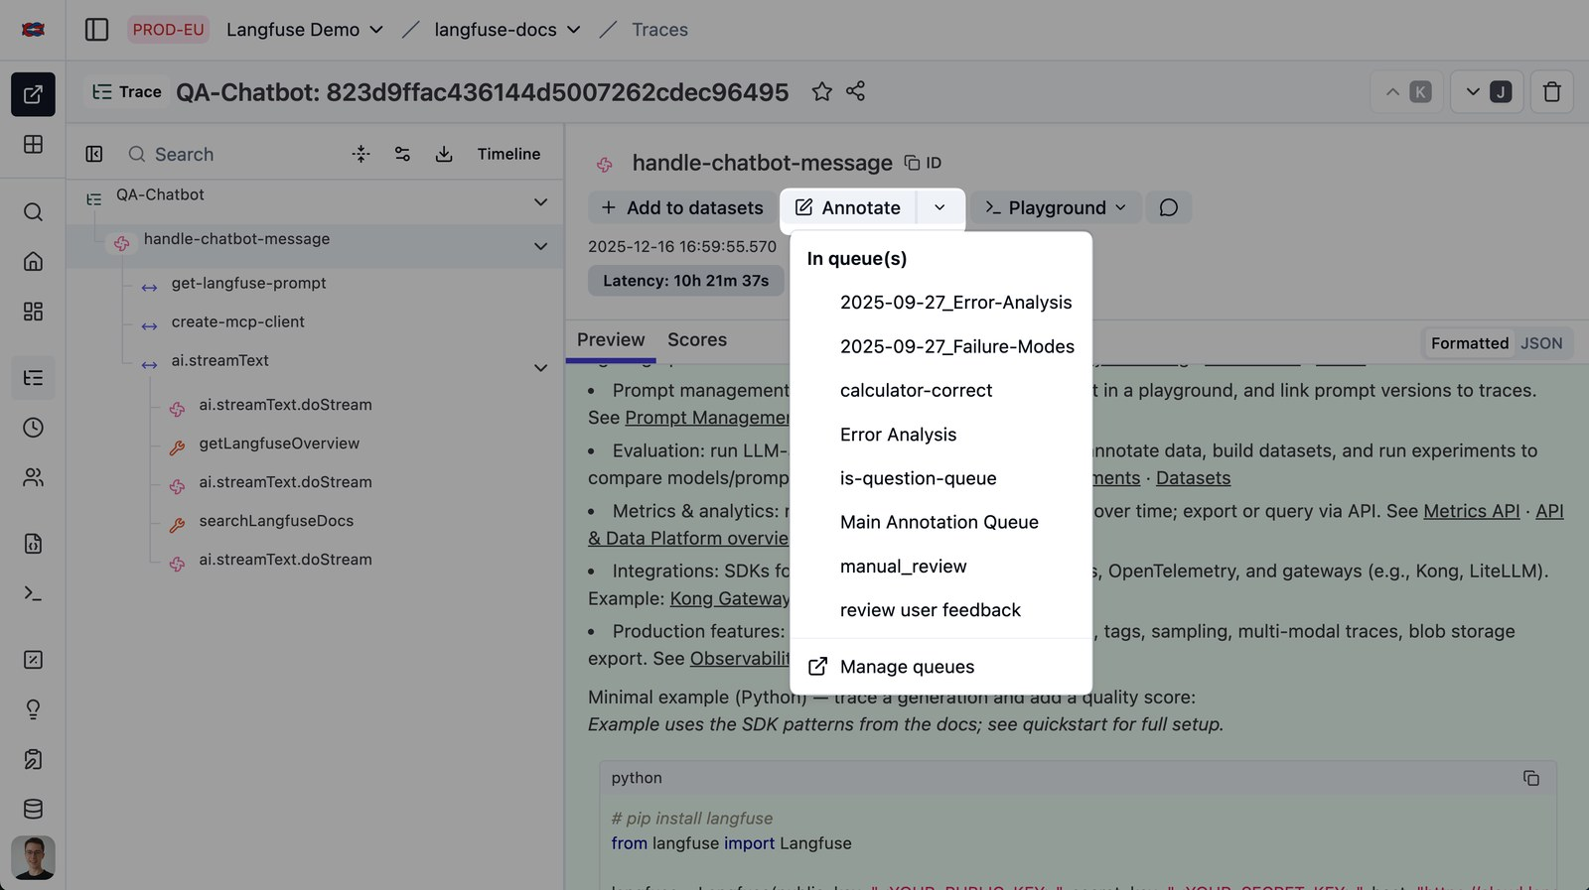
Figure 16. Sending an agent trace to a human annotation queue from the trace view.
Source: Langfuse docs, Annotation queues

Arize AX
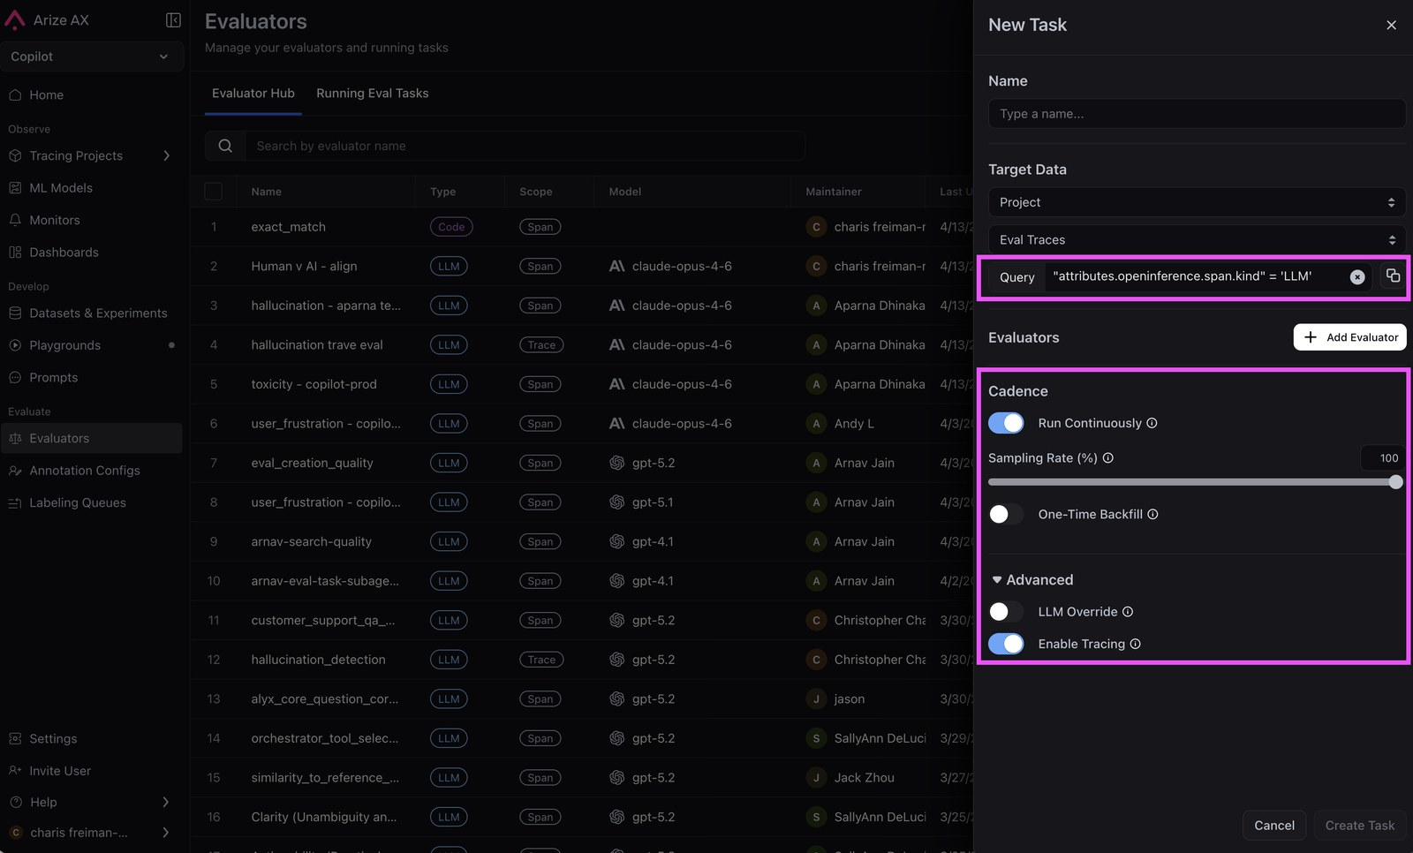
Figure 17. Configuring an online evaluation task: target data filter, evaluators, continuous run and sampling rate.
Source: Arize docs, Run evals on traces
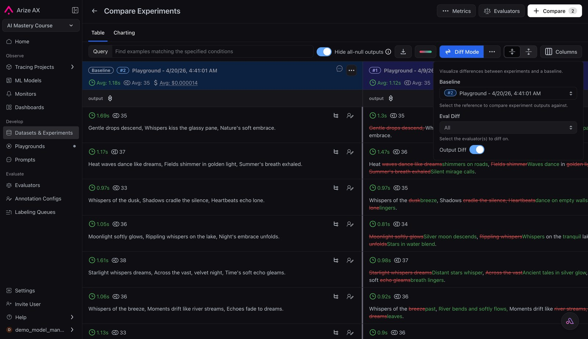
Figure 18. Compare Experiments in diff mode: output differences, latency, tokens and cost against a baseline run.
Source: Arize docs, Prompt playground

